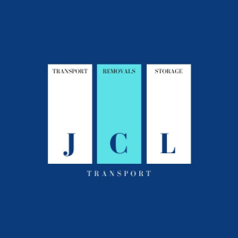
JCL REMOVALS

Itinerary
Please fill out the form below. Please then check to see if all of the information below is correct and then sign and return to confirm that you agree.
Customer name
Collection date
Delivery date
Collection address
Delivery address
Terms | I declare that my load will not exceed 1000kg or 20 cbm.
 | List of items | Qty | Weigh in kg | Value in £
 |  | Total packages
 |  | Total weight in kg
 |  | Total value in £

I declare in my honour that the item was bought more than six months ago.
Please sign below to confirm all the information above is correct.

Customer Signature…………………………………Date…………………….

